Internal Rhyme in Couplet

🎯 What is Internal Rhyme in Couplet
# Source: AI Source: Provided by: [Data Path: Persons Table -> ID Column: 1, Name_En Column: Motasem Essam] -> From: [Chatgpt (GPT-4-turbo)] on [8/2/2025]
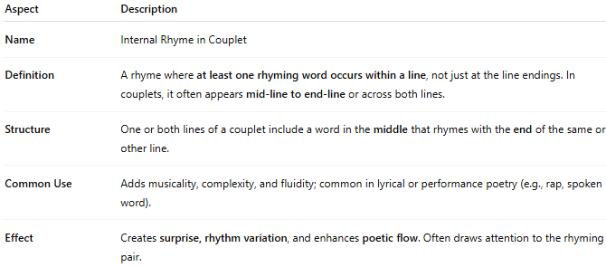
Aspect | Description
Name | Internal Rhyme in Couplet
Definition | A rhyme where at least one rhyming word occurs within a line, not just at the line endings. In couplets, it often appears mid-line to end-line or across both lines.
Structure | One or both lines of a couplet include a word in the middle that rhymes with the end of the same or other line.
Common Use | Adds musicality, complexity, and fluidity; common in lyrical or performance poetry (e.g., rap, spoken word).
Effect | Creates surprise, rhythm variation, and enhances poetic flow. Often draws attention to the rhyming pair.

✅ Examples of Internal Rhyme in a Couplet

1. Same-Line Internal Rhyme (Mid to End in One Line):
# Source: AI Source: Provided by: [Data Path: Persons Table -> ID Column: 1, Name_En Column: Motasem Essam] -> From: [Chatgpt (GPT-4-turbo)] on [8/2/2025]
He sang with flair and bold despair.
The flame of night burned fierce and bright.
- "sang" / "flair" (internal rhyme within first line)

2. Cross-Line Internal Rhyme (Mid in Line 1 to End of Line 2):
# Source: AI Source: Provided by: [Data Path: Persons Table -> ID Column: 1, Name_En Column: Motasem Essam] -> From: [Chatgpt (GPT-4-turbo)] on [8/2/2025]
The rain came fast and struck the pane,
It thrashed the glass with howling pain.
- "rain" (middle of Line 1) rhymes with "pain" (end of Line 2)

🧠 Key Insight:
# Source: AI Source: Provided by: [Data Path: Persons Table -> ID Column: 1, Name_En Column: Motasem Essam] -> From: [Chatgpt (GPT-4-turbo)] on [8/2/2025]
- Internal rhymes in couplets enrich the traditional A-A rhyme scheme with extra layers of sound-play.
- They are often found in more modern or stylized verse, including hip-hop lyrics, sonnets, or nursery rhymes.

